AIM:
To determined Shear Test of Steel.
OBJECT:
To conduct shear test on specimens under double shear:
APPARATUS:
i)Universal testing machine.
ii) Shear test attachment.
iii) Specimens.
THEORY:
Place the shear test attachment on the lower table, this attachment consists of cutter. The specimen is inserted in shear test attachment & lift the lower table so that the zero is adjusted, then apply the load such that the specimen breaks in two or three pieces.
If the specimen breaks in two pieces then it will be in single shear & if it breaks in three pieces then it will be in double shear.
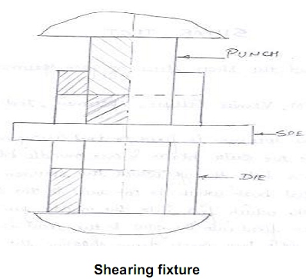
PROCEDURE:
1. Insert the specimen in position and grip one end of the attachment in the upper portion and one end in the lower portion.
2. Switch on the main switch of universal testing machine machine.
3. The drag indicator in contact with the main indicator.
4. Select the suitable range of loads and space the corresponding weight in the pendulum and balance it if necessary with the help of small balancing weights.
5. Operate (push) buttons for driving the motor to drive the pump.
6. Gradually move the head control level in left-hand direction till the specimen shears.
7. Down the load at which the specimen shears.
8. Stop the machine and remove the specimen
Repeat the experiment with other specimens.

OBESERVATION:
Diameter of the Rod, D = ….. mm
Cross-section area of the Rod (in double shear) = 2x π/4x d2 =.. mm2
Load taken by the Specimen at the time of failure , W = N
Strength of rod against Shearing = ƒx2x π/4x d²
ƒ = W / 2x π/4x d² N/mm²
RESULT:
The Shear strength of mild steel specimen is found to be
= ……………… N/mm2
PRECAUTION :
1 The measuring range should not be changed at any stage during the test.
2. The inner diameter of the hole in the shear stress attachment should be slightly greater than that of the specimen.
3. Measure the diameter of the specimen accurately.
VIVA-QUESTIONS :
· Does the shear failure in wood occur along the 45° shear plane ?
· What is buldging? Why does it occur?
· What is single & double shear ?
· What is find in shear test?
· What is unit of shear strength ?

PART – 2
ANIMATION STEPS


PART – 3
VIRTUAL LAB FRAME

